Hiking Haleakala

This book captures one of the dumbest and most challenging excursions I have ever undertaken: hiking Haleakala from one end to the other. In roughly 12 miles, the hike included a 1,400 foot descent to the crater floor, and a 2,500 foot ascent out to the top in the last four miles, taking me less than six hours, two quarts of water, and perhaps some hypothermia and altitude sickness. All recommend taking the hike from the top down and out. No one, including myself, recommends starting at the bottom. It is entirely too strenuous, and places you at the greatest risk of cold and exhaustion at the highest elevation and least air.

Haleakala, House of the Sun, was the shield volcano that formed East Maui. Today, it is dormant, not extinct, having last erupted in 1790. Once several thousand feet higher, now 10,000 feet high, it is now the result of erosion, followed by successive periods of eruption. It is now referred to as a valley, not a crater. It is 7 ½ miles long, 2 ½ miles wild, and 21 miles in circumference.

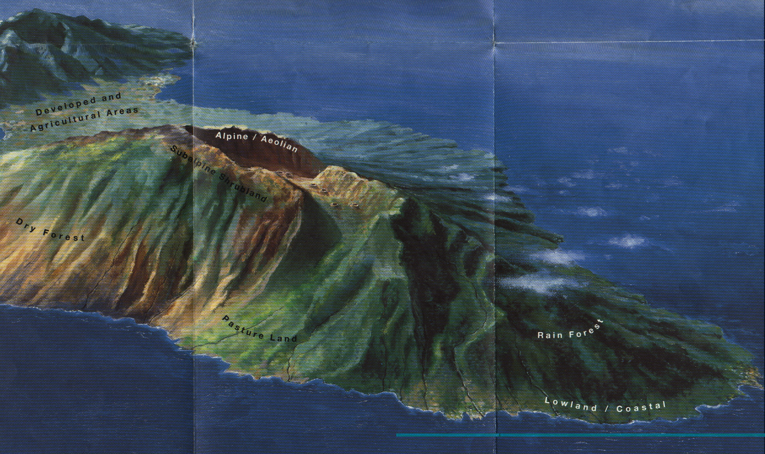
Heleakala is a mystical, magical place, unlike any other. Revered by the natives, many consider it one of the few “energy vortex” locations in the world, along with Mt. Shasta, Sedona, and Machu Pichu. Many travel to the top to view the sunrise, which is supposed to be spectacular, and romantic.

These pictures may reveal some of that magic. I can relate the attraction it holds for me, having been compelled to visit it during every trip to Maui. a haleakala artwork.jpg

Driving by auto from sea level covers one of the quickest 10,000 foot ascents in the world.

This book documents my crater hike from its beginning at the bottom, with a 1,400 foot descent, across the crater, and up and out the top, a 2,500 foot ascent in less than four miles. And probably 3,000 feet of vertical gain in all. Four miles to climb 2,500 feet may seem like a gentle climb, until you try it.

Links are provided to each of the pictures in this book. Many pictures reveal more detail when enlarged using software than can manipulate JPEG photos.

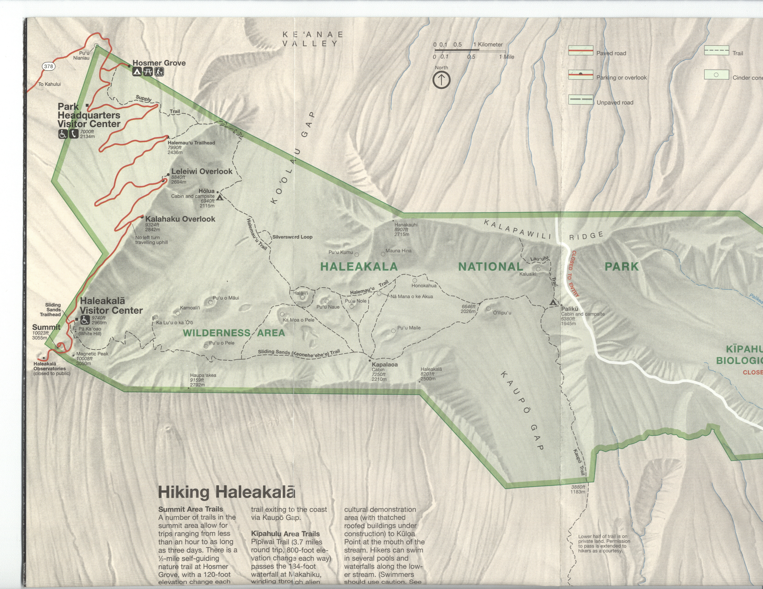
Viewing the map to the right, aa haleakala map.jpg, the hike began at the Halemau’u Trailhead (7,990 ft), proceeded down into the valley, up to the Holua Cabin (6,940 ft), up and across the Alpine terrain and the “recent” lava flows to the cinder cone area, up to the Sliding Sands Trail, and out to the top exit (9,800-9,900 ft).

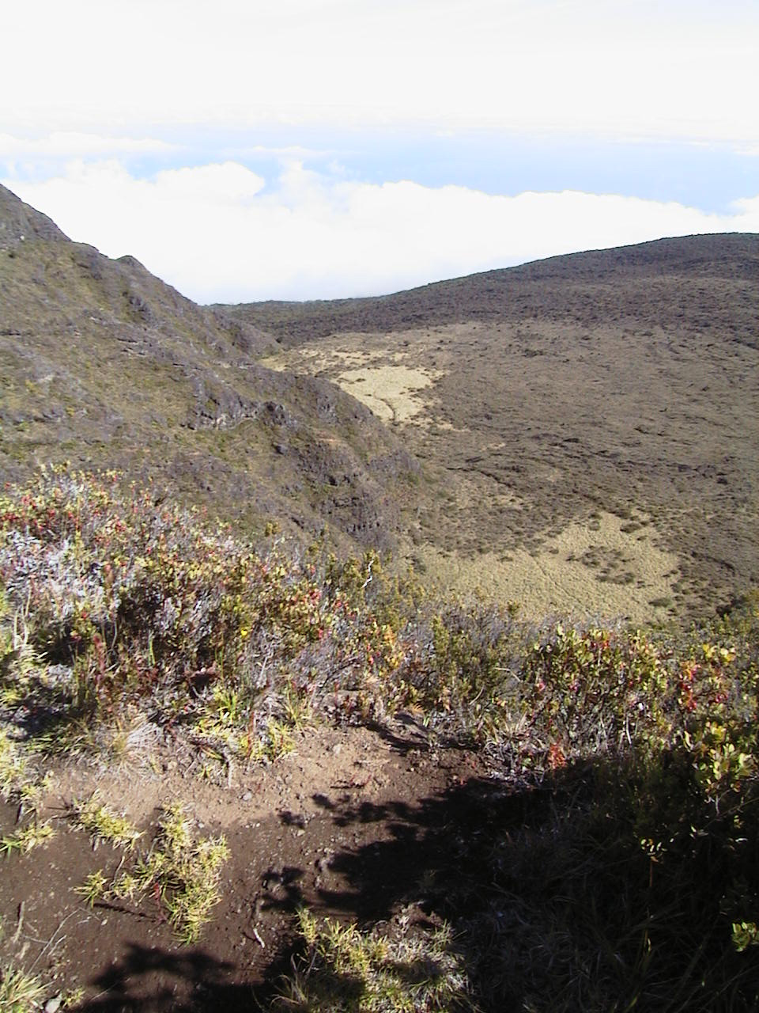
After a short hike through brush from the parking lot, you come out on a narrow ridge, only a few feet wide, that you must walk/crawl across to begin the hike down. It’s 1,400 feet almost straight down, and it offers the most panoramic view of the valley. In the picture to the right,Aut_5706-looking-down-left 1.jpg , the switchbacks down to the floor are on the mountainside to the left. Also, you can get a sense of the edge of the crater gap to the rear left, with the clouds below. Elevation at this point is just under 8,000 feet.

The picture below shows the broad alpine valley panorama from this vantage point Aut_5701-looking-down 2.jpg.

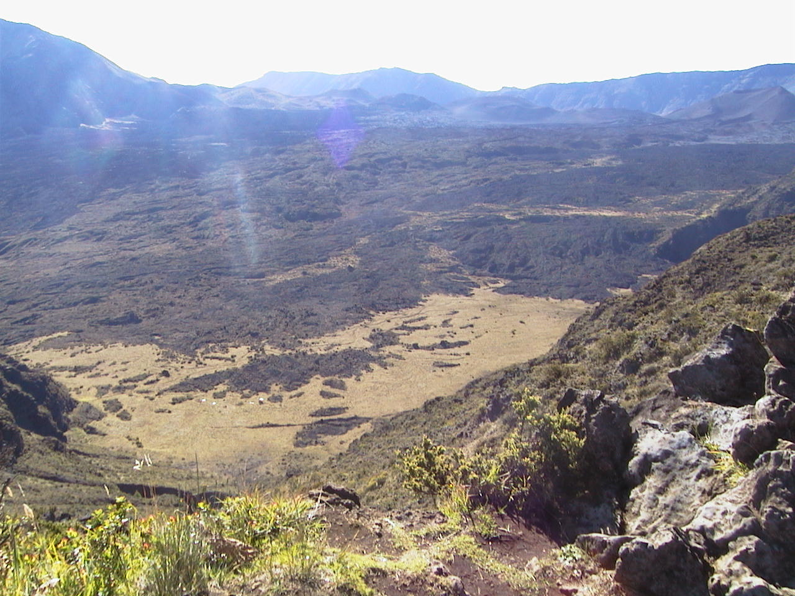
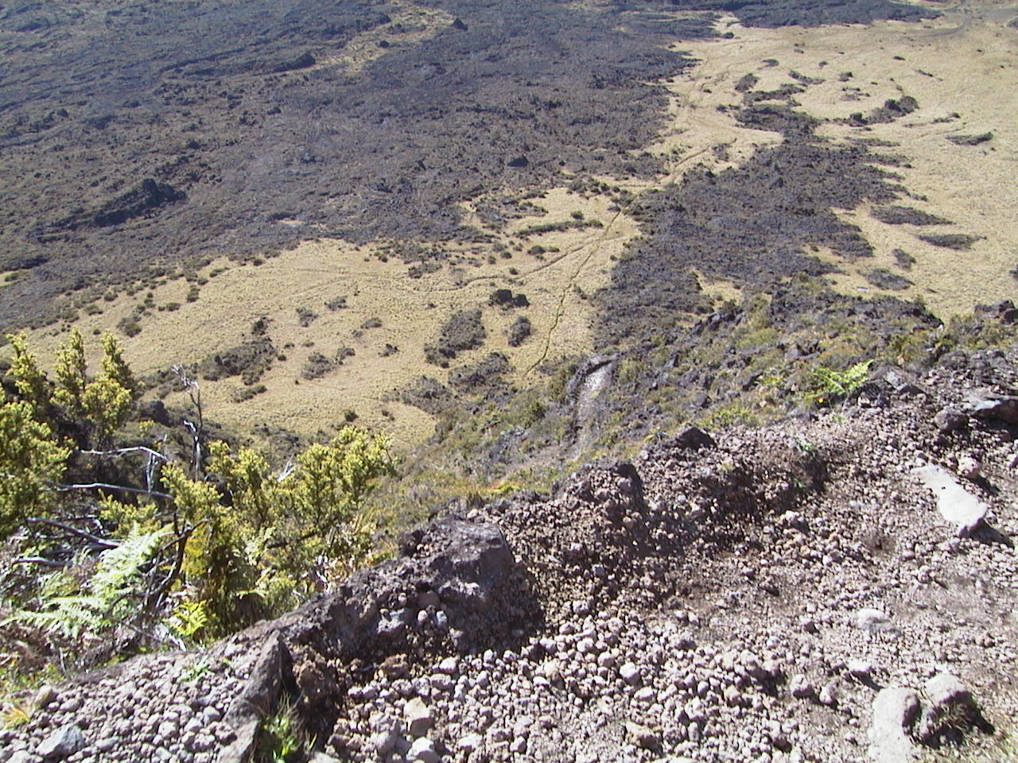

Looks pretty straight down, doesn’t it? How far? 1,400 feet. (140 stories). Aut_5704-straight-down 4.jpg

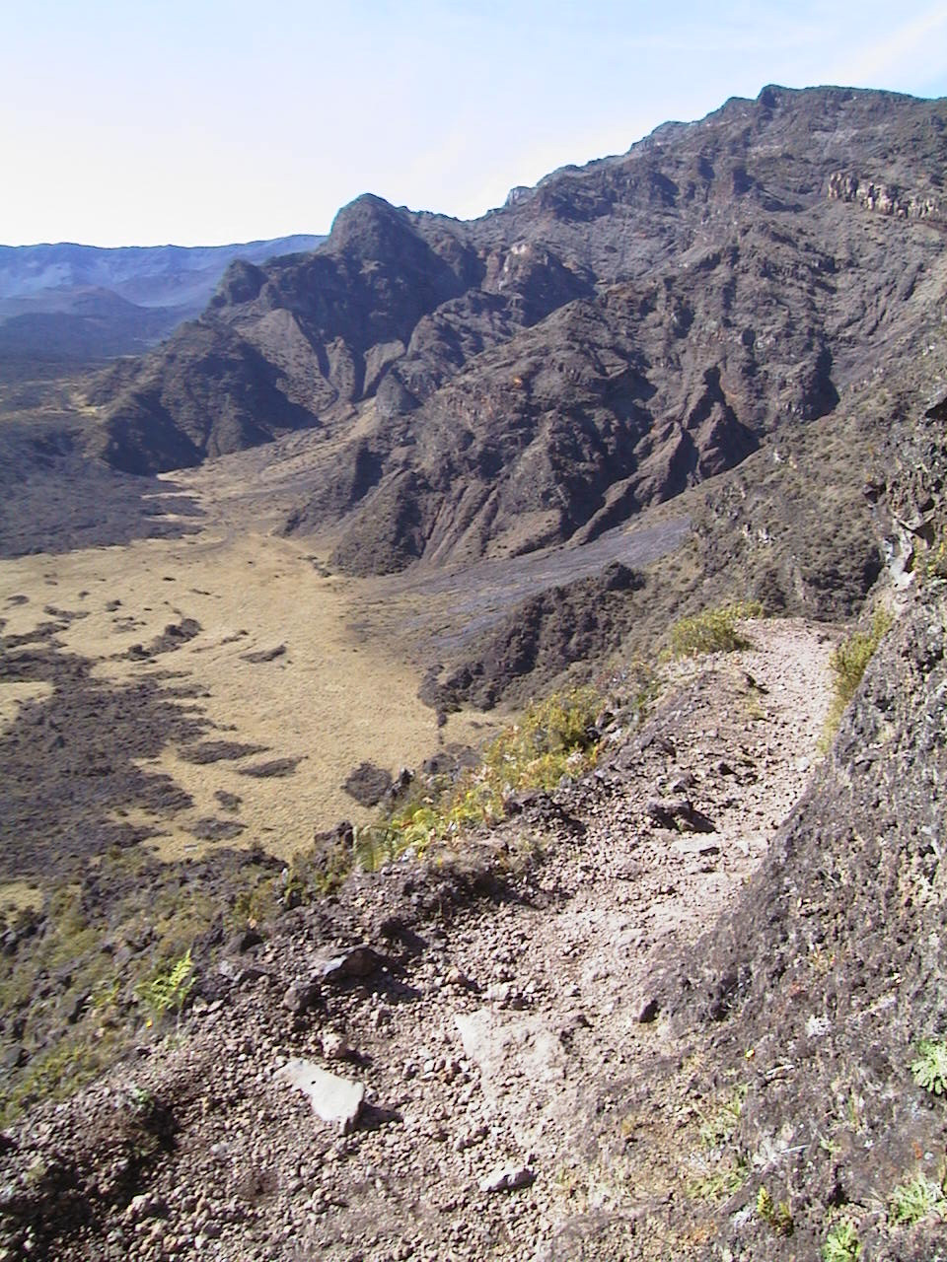

This picture shows the crater rim to the right, or West, of the switchback trail down. Aut_5705-down-and-right 3.jpg

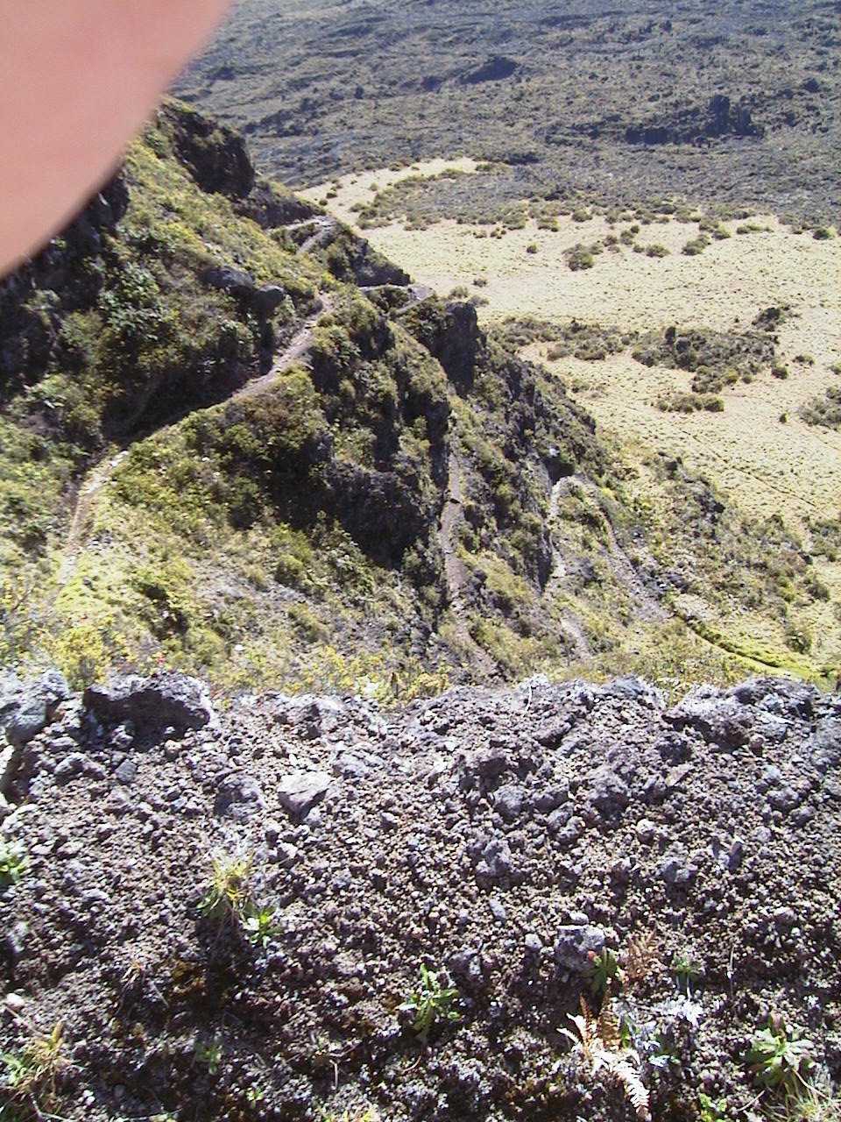

The trail down consists of narrow, rocky switchbacks down the side of the rim, and is also used by horses. What happens when you encounter a horse? Pardon the finger, but it was stressful to lean over the edge and shoot the trail. Aut_5708-switchbacks 6.jpg

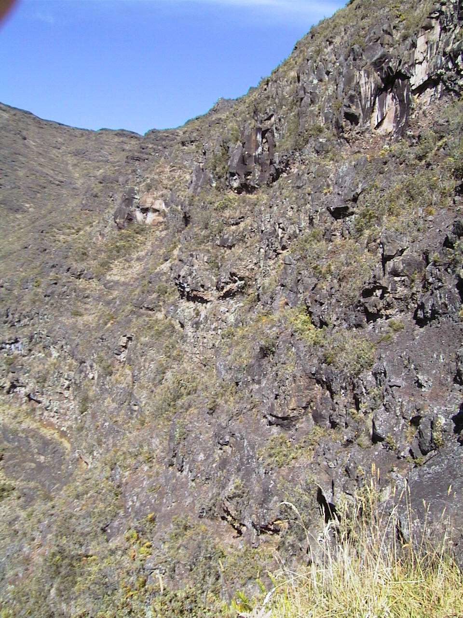

Once at the bottom, this is what the rim looks like. Up there somewhere was the ridge where the previous pictures were taken. Aut_5710-looking-back-up 7.jpg

Ah, gently sloping, soft ground through some kind of alpine grass. Some of the switchbacks may be visible in the background. Aut_5716-looking-bac-up-and-trail 8.jpg

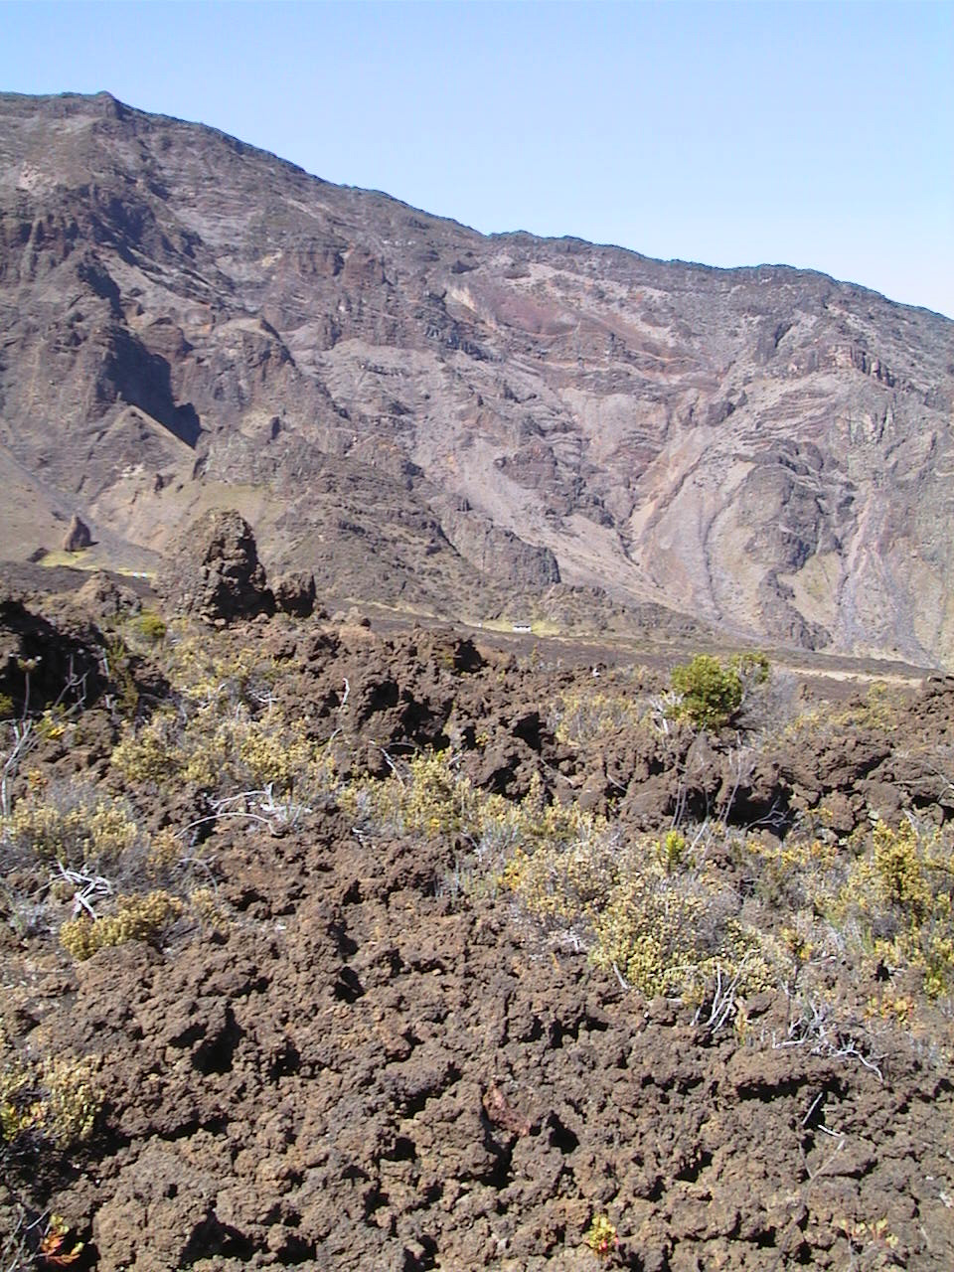

Oops. So much for a smooth dirt trail. Now it’s become rough lava rocks. Lava layers can be seen on the rim side in the background. At this point the trail becomes rocky and follows a fairly rapid rise to the upper crater. It’s a fairly long trek across this lava flow region. Aut_5719-alpine-side 9.jpg
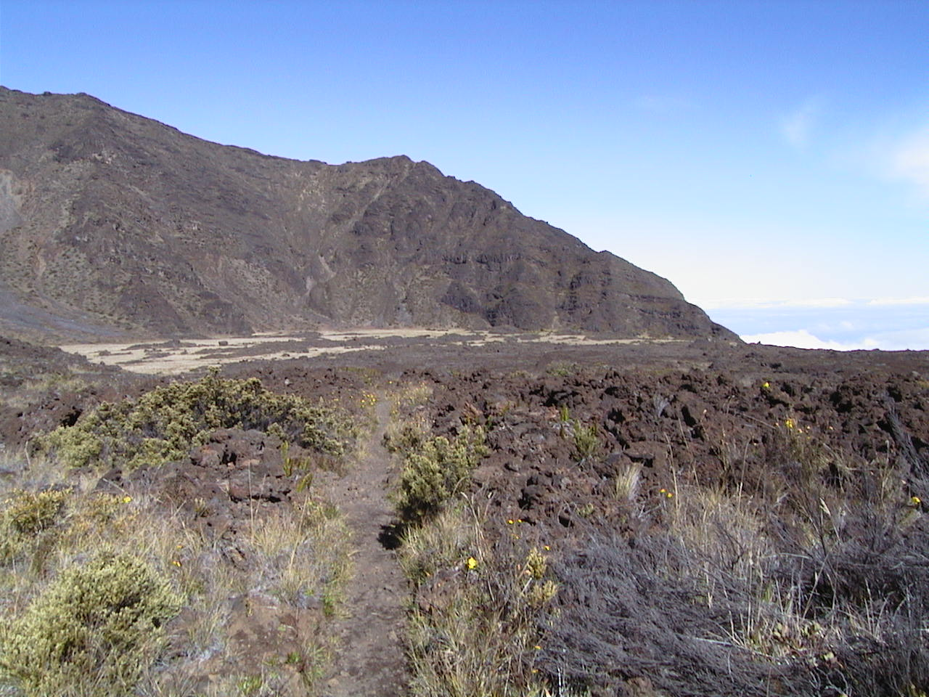

One more look back from something of a crest in the lava flow rise, showing the ascent to this point. The switchback rim-side is in the background. And the clouds below the gap are also visible to the back right. Pretty neat to be above the clouds up here. Aut_5717-looking-back-and-trail 10.jpg

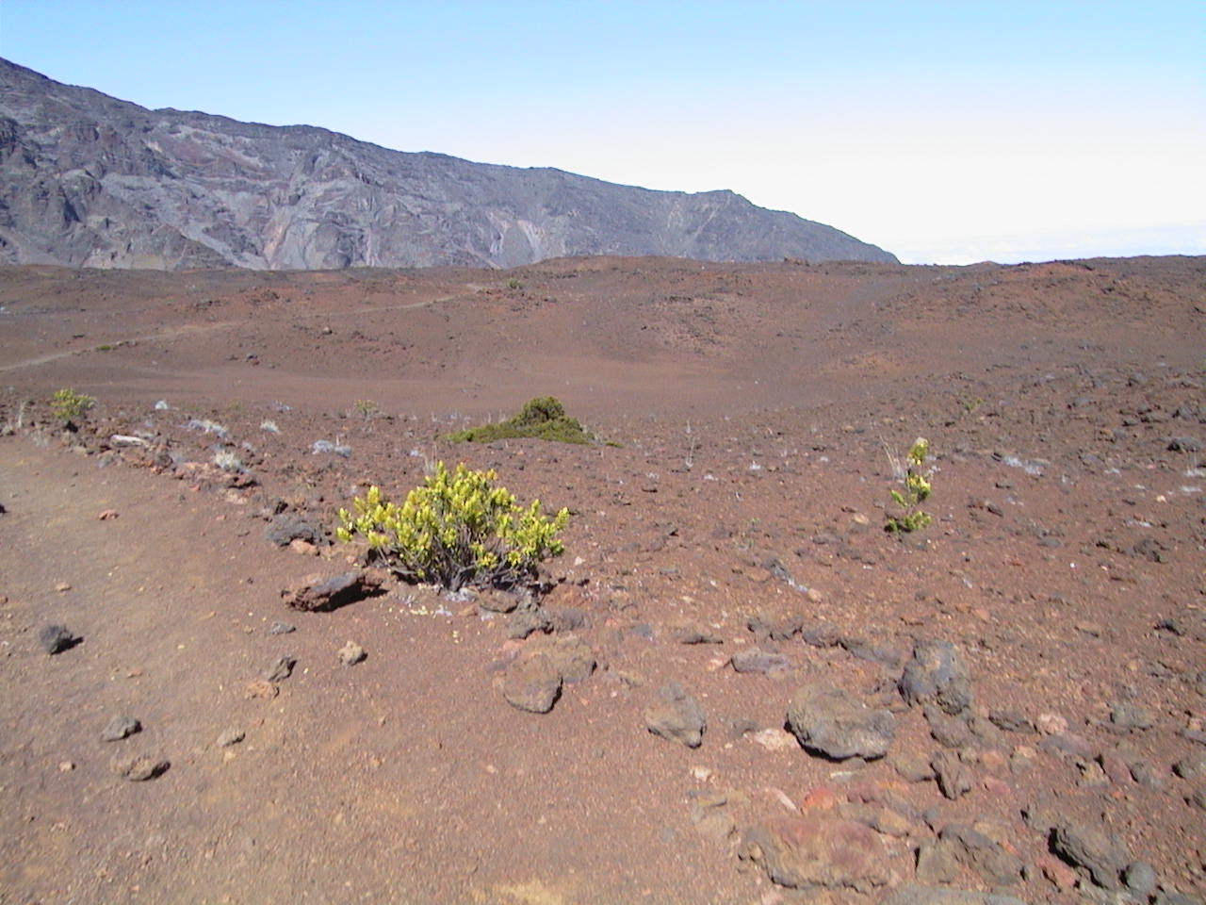

Boy, what looked level from above provides a very different hike on the crater floor. Another look back across what’s become a sandy lava field. What next? Aut_5723-back-at-lava-trail 11.jpg

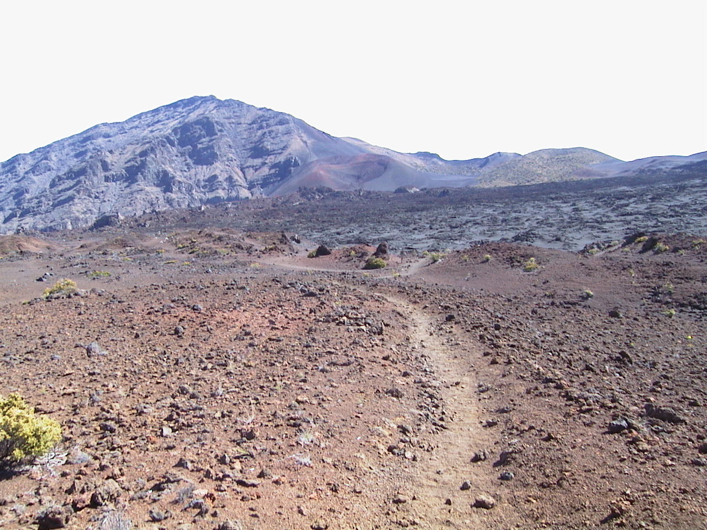

The forward trail view promises more ascent over a rocky, sandy field, heading towards the far rim. All of this was part of a relatively recent eruption and lava flow. A cinder cone comes into view. What else lies ahead? At this point, with full sun and no clouds overhead, it becomes warm and extremely dry. It’s so dry, your sweat dries before it wets your skin. Aut_5724-more-lava-flow-trail 12.jpg

Breaking over the top of the lava flow ridge, sand and cinder cones come into view. Sometimes the trails a little hard to spot, but it’s there. Getting closer to the upper moonscape part of the crater. Oh look, it seems downhill for a while. Maybe. The scale is so mysterious, what seems flat from a distance, isn’t. What seems uphill, may or may not be, and vice-versa. Aut_5721-trail-over-lava-flow 13.jpg

Wow. A lunar landscape. Rumor has it NASA was considering this area for practicing lunar landings. Good choice. It looks like a significant descent from here, but it really isn’t, or is it? This area is near the eastern Kaupo Gap, across from where the hike began, and from where it will eventually end. Aut_5722-trail-down-to-cones 14.jpg

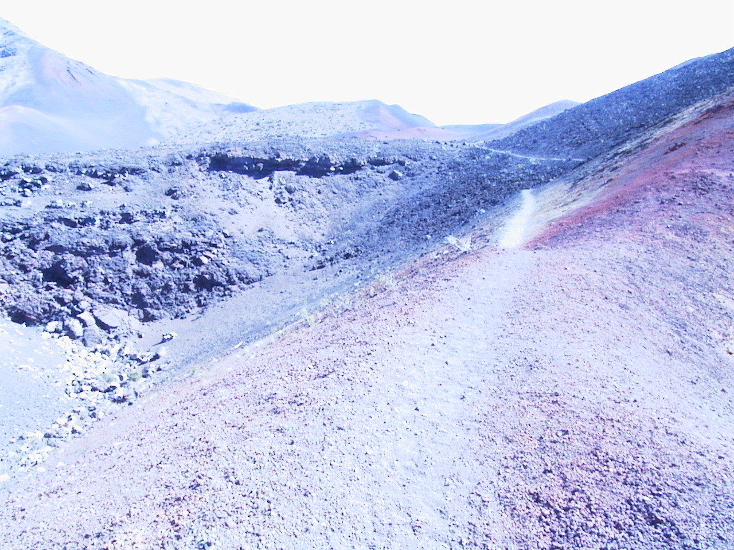
At this point in the trail, in the heart of the most recent eruption cinder cones, a very strange change occurred with the colors recorded by the camera. This happened only one other time near a relatively recent eruption near Sedona, AZ. Fact or fiction? What exactly are “energy vortexes”? Whatever they are, this one keeps drawing me back to it. As can be seen, the trail winds on and on among cinder cones that are much bigger up close. And a strange mix of colors. Aut_5726-into-sand-trail-around-cones 15.jpg

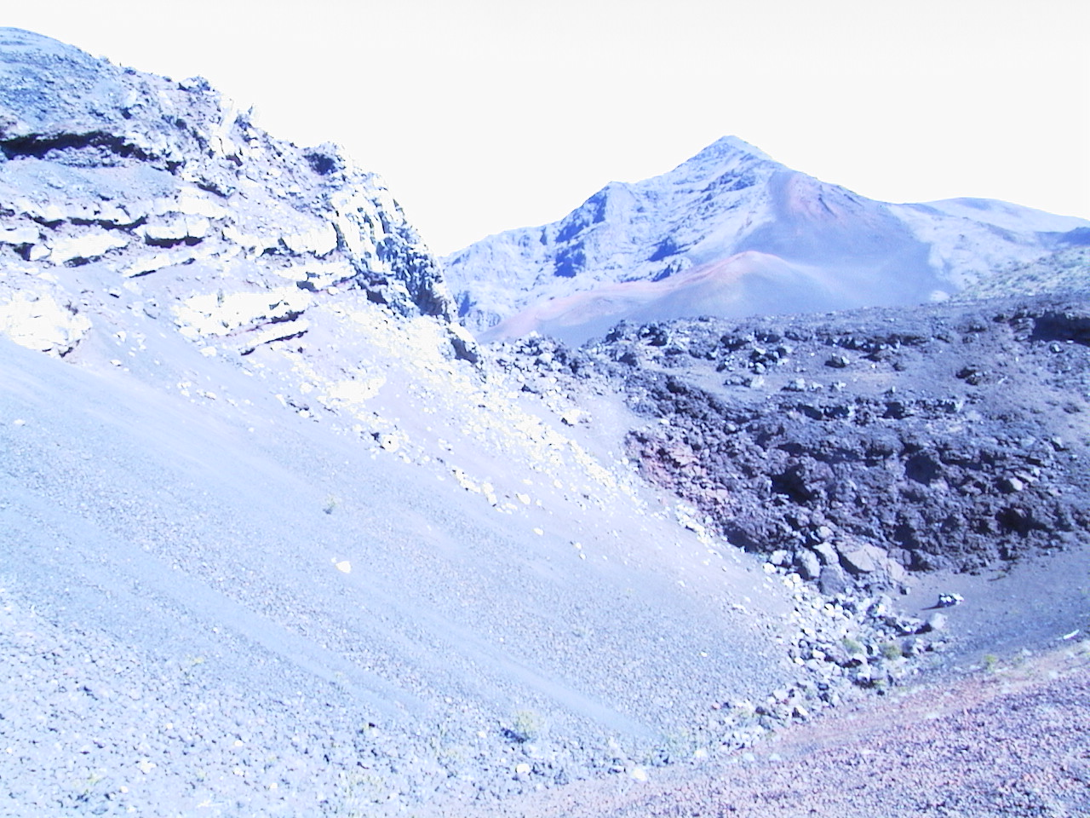
The formations, lava flows, and colors are very intriguing here, very near the edge of the Kaupo Gap. The camera is still acting strange.
Aut_5727-toward-end-of-pass-hike 16.jpg

What an eerie landscape, as the hike moves closer to the upper rim, and away from the eastern side. But it still looks pretty far down from here. Or is it?
Aut_5728-on-into-cone-area 17.jpg

Moving through this cinder cone area, the trail winds on, and the nearest cones reveal a little more about their true size. Aut_5729-more-cone-area-trail 18.jpg

Near the eastern, Kaupo Gap, or valley to the ocean, is the “Bottomless Pit”, which holds some mystery to the natives. But it’s actually only about seventy feet deep, a former gas vent. Only 70 feet. But now that the hike has moved through the densest area of new cinder cones, the camera suddenly works properly again. Or did it ever malfunction? Ah, the mystery of energy vortexes, and nature. Aut_5730-bottomless-pit 19.jpg

This point was near the southern rim and the Kaupo gap. Lots of interesting smaller, newer lava flows, and smaller cones. At this point, the trail is wrapping around a large cone to the right. From here the trail heads West toward the Shifting Sands Trail and the climb out. This was probably the wrong trail, and the hike was actually closer to 14 or 15 miles, instead of 12. But with the scale, the perspective hidden by the rises, flows and cones, and the thin air, it’s probably easy to get slightly disoriented in this area. Not to mention the energy flow. Aut_5732-trail-continues 20.jpg

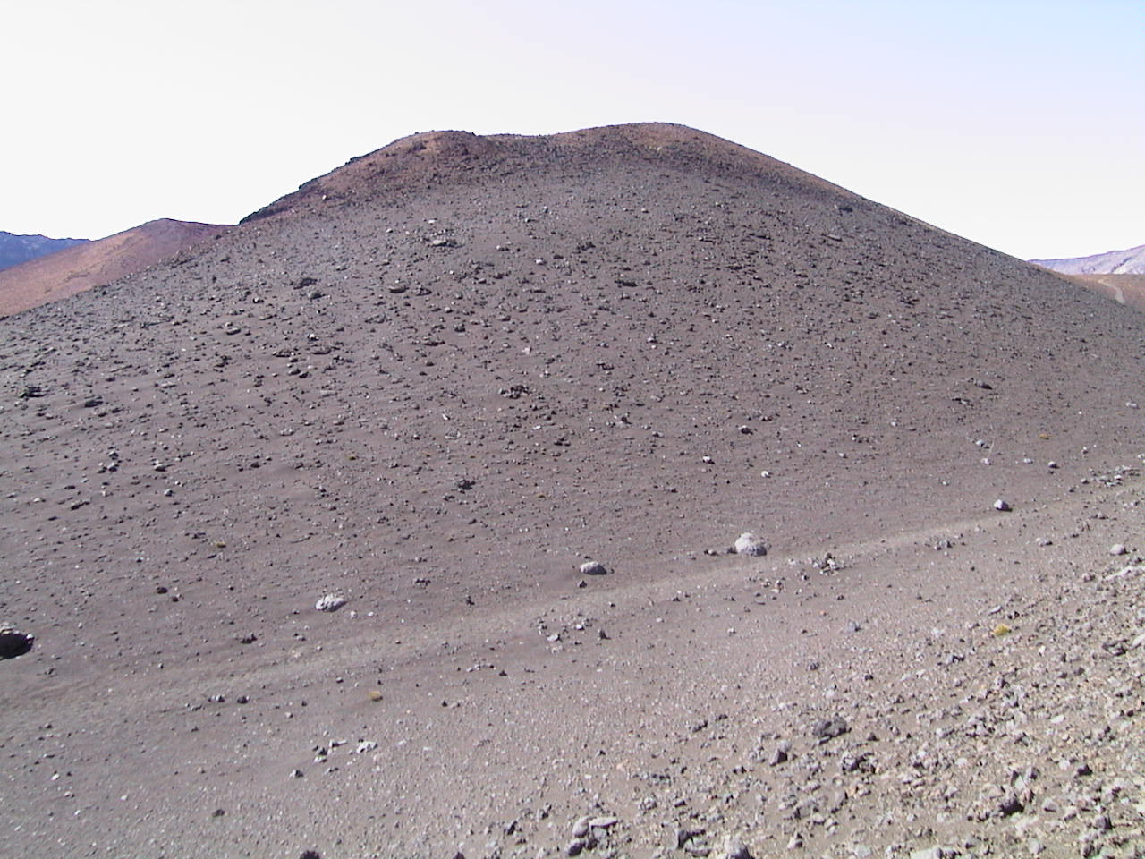

This was one of the larger cones a little more to the West, and there’s a much redder one in the background. The scale is difficult to determine from this picture, but it’s probably at least 70 feet high. Aut_5733-cones-anyone 21.jpg

A look back, while climbing a rise, to view the trail winding back to the right corner of the picture. The eastern gap is the the right of the rear peak, and the northern gap is to the left of it. Seems like the trail has meandered quite a ways at this point. Why wasn’t there a shortcut? Aut_5734-looking-back-cone-trail 22.jpg

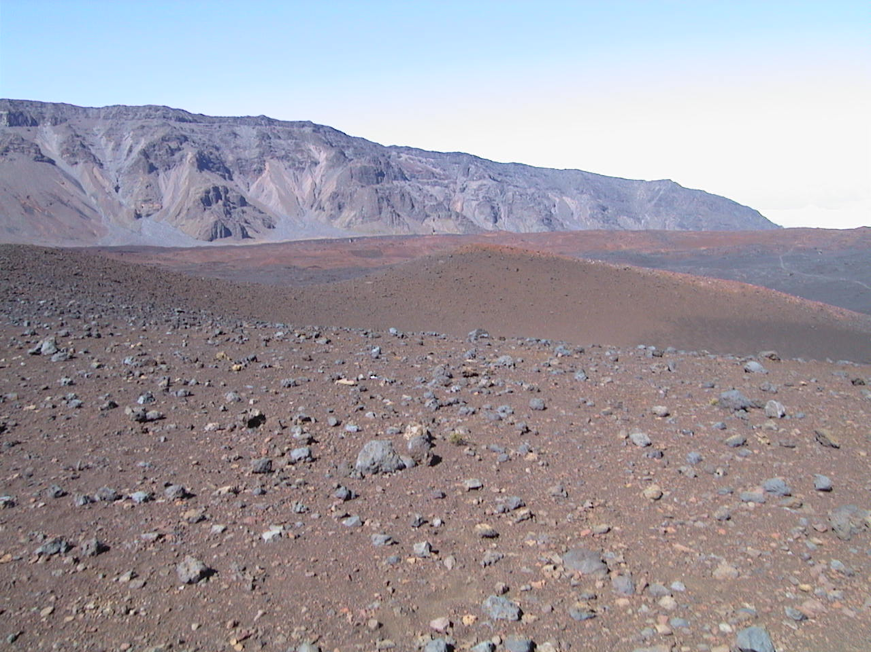

Where is the trail now? The western rim is in the background, and the beginning point at the far right of the rim. The lave flow ridge crossed a long time ago is clearly visible. The Sun is changing the colors, as it is known to do in the crater, depending on it’s location relative to the picture, and the time of day. There may be a trace of the earlier trail to the back and right. Aut_5736-looking-back-to-start 23.jpg

Looking westward, the trail wanders on quite a while on fairly level terrain, before the true climb out. Where exactly is the exit point? Someplace on the back rim in the middle of the picture. I think. Doesn’t look like a 2,500 foot climb out from here, does it? Once again, ridges, rims, cones, and the sheer scale makes direction-finding a challenge. More cones and sand. But the trail’s end is approaching, thankfully. Aut_5737-down-toward-cones 24.jpg

The Hike has reached the Shifting Sands Trail, and the Trail Junction, with the Southern Rim in the background. From here the trail bends to the right around the ridge in the background, which is probably a half-mile ahead. It’s been quite a while since plant life has been spotted because of the dry elevation. The climb out begins gently.
Aut_5738-starting-shifting-sands-up 25.jpg

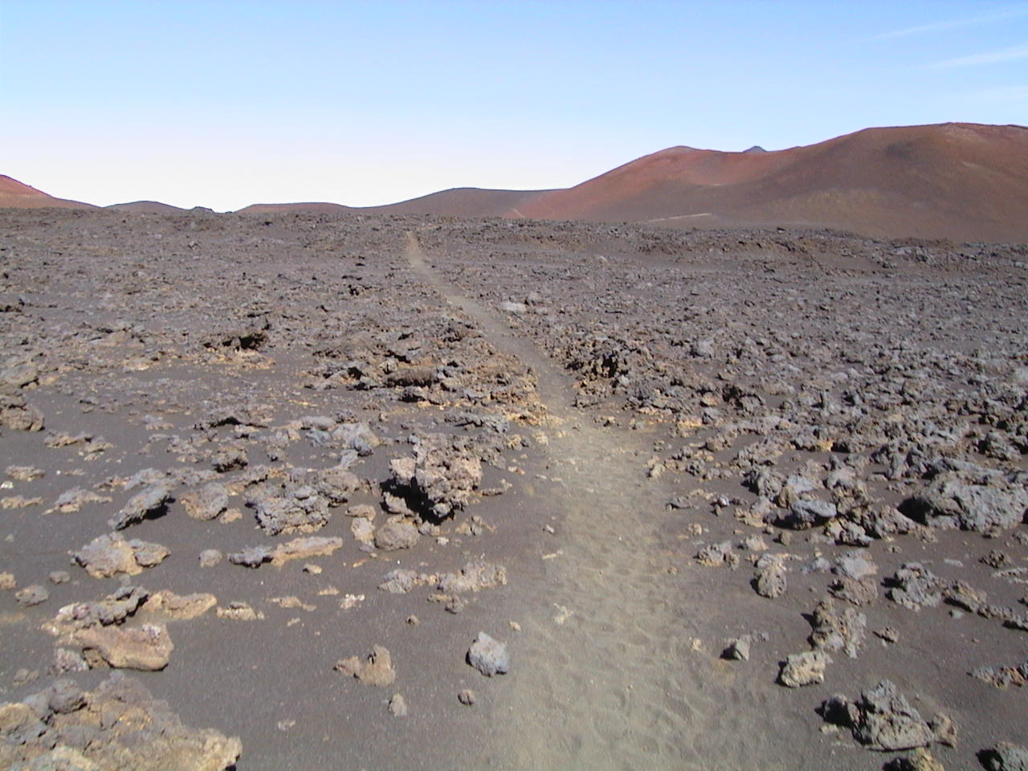

A look back. Once again, the perspective changes dramatically. This was one of the longer reaches across relatively flat terrain. But a slight rise is visible.
Aut_5739-looking-back 26.jpg

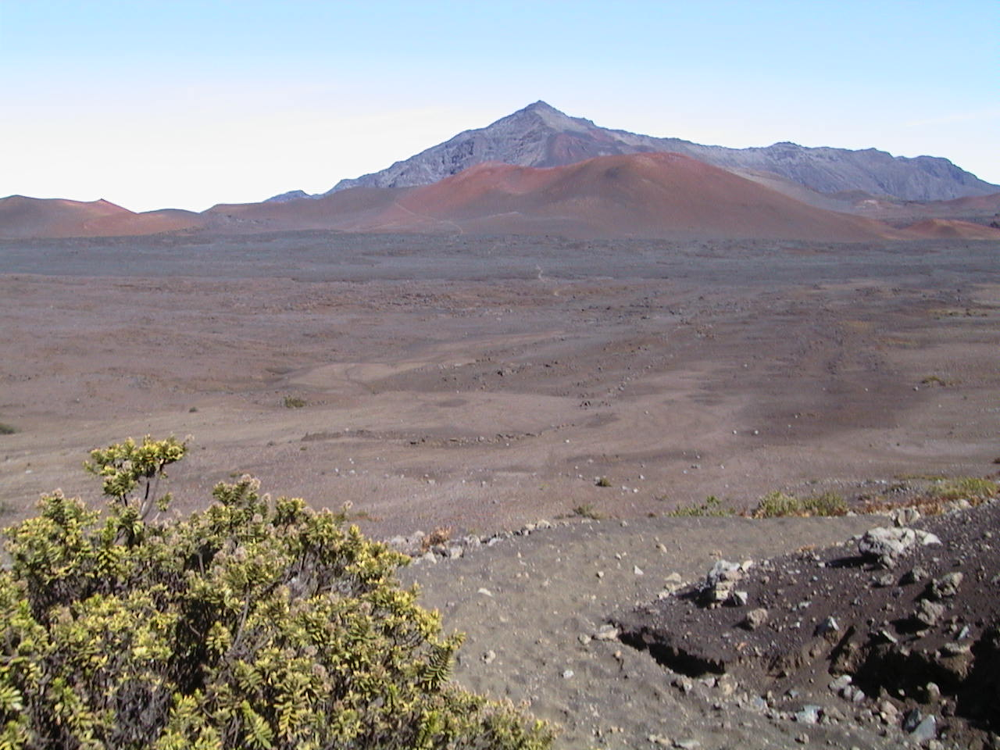
One more look back as the climb out really begins. The entry point is left of this picture, and the Kaupo Gap is to the back right. At this point, total exhaustion from the climbing, elevation, and time on the trail is beginning to set in. The Shifting Sands climb out always requires a different, slower pace and shorter stride to maintain progress. At least for mortals. Now, energy becomes focused on getting out, not taking more pictures. The thought occurs that stopping for a rest might be a really bad idea. Aut_5740-shifting-sands-starts-climbing 27.jpg

